

RESPONSE INDICATOR [ RI ]

MODEL RI-20(P) [WHITE]

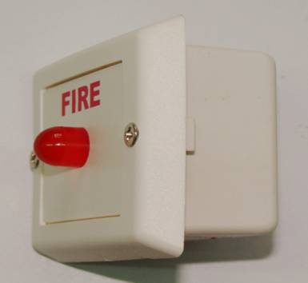

Specifications:

Operating voltage : 24V DC (max).

Current consumptions : 10mA.

Cabinet material : ABS Plastic.

Cabinet Color : White.

Mounting : Surface/Flush Mount (back box)

Dimensions : ( 66L x 57H x 33D )mm.

Applications : Fire alarm

JORDAN SAFETY SYSTEMS. AN ISO 9001:2000 CERTIFIED COMPANY.

