

EM LOCK

MODEL IEL-210

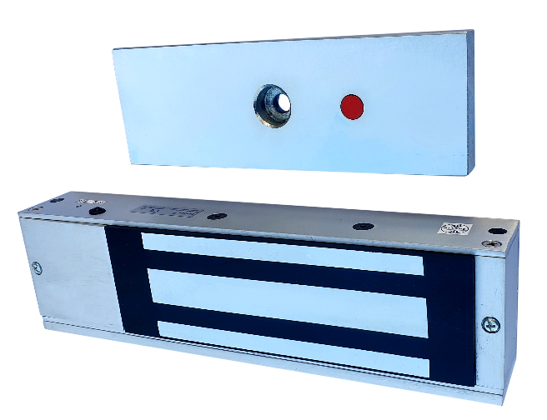

Specifications
Model | IEL-210
Operating Supply | 12V/24V (Selectable)
Current Consumptions | 500mA @ 12V/ 250mA @ 24V
Pulling Force | 1200 LBS
Lock status indication | LED provided(power to red)
Construction Material | Aluminum
Mounting Type | Surface Mount
Weight | 5Kgs (Approx)
Lock Size | [267L x 74W x 43H]mm
Armature plate size | [185L x 61W x 16H]mm
Applications | In swing & out swing doors

JORDAN SAFETY SYSTEMS. AN ISO 9001:2000 CERTIFIED COMPANY.

