

EMERGENCY PULL CHAIN

MODEL IMPC-10(P) GREEN

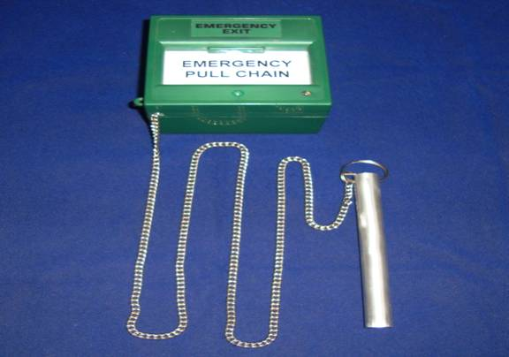

Specifications
Model | IMPC-10(P)GREEN
Descriptions | Emergency pull the Chain to trigger the Alarm Unit
Contact & Voltage Rating | 10A @ 250V AC.
Contact Arrangement | COM, NO, NC
Contact Function | Momentary Operation
Construction Material | ABS plastic
Available Color | Green
Available Contact type | SPDT
Status Indication | LED
Mounting Type | Surface Mount.
Weight | 135 Grams.
Size | 86L x 50D x 86H mm
Applications | Emergency and Access Control systems.
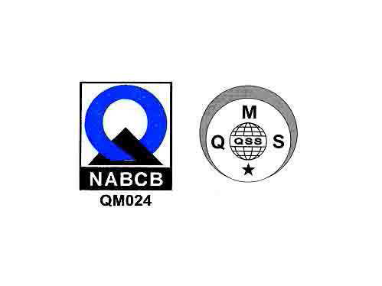
JORDAN SAFETY SYSTEMS. AN ISO 9001:2000 CERTIFIED COMPANY.

