

FIRE ALARM PANEL

MODEL IFP-04

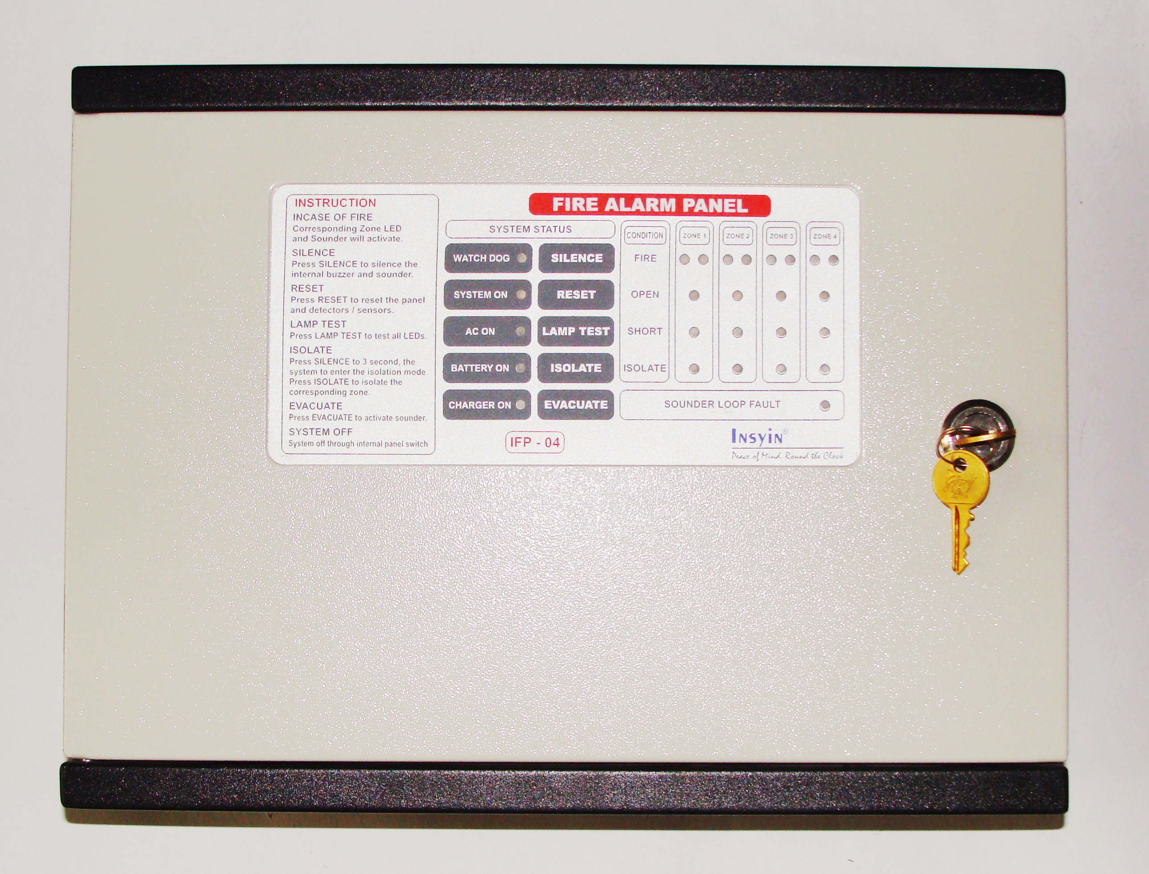

SPECIFICATIONS
MODEL | IFP-04
TYPE | CONVENTIONAL MICRO CONTROLLER BASED FIRE PANEL
OPERATING SUPPLY | 230V AC, 50HZ ± 10%
STANDBY POWER | 24V DC
OPERATING TEMPERATURE | 0°C TO 49°C ± 2°C
OPERATING HUMIDITY | 95% ( NON - CONDENSING )
NO. OF ZONES | 4 ZONE PANEL
COLOR | BLACK WITH SIEMENS GREY [ STRUCTURE FINISH ]  DUAL COLOR
DIMENSIONS | 350W × 263H × 103D in MM
WEIGHT | 5 Kgs( Approximate )

JORDAN SAFETY SYSTEMS. AN ISO 9001:2000 CERTIFIED COMPANY.

