

MCP WITH SOUNDER

MODEL MCP-FS10(M) [RED]
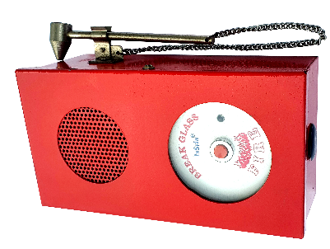

SPECIFICATIONS:

Operating voltage : 12/24V DC( Select).

Current consumption : 75 mA @ 12VDC.
100mA @ 24VDC.
Sounder type : piezo Electric type.

Variety of sounds : Police Siren, Fire engine siren,
Ambulance Siren, Machine Gun.
Sound level : 120 dB.

Visible Indications : 5mm Red LED.

Activation : Press to alarm (Glass breakable)

Contact Ratings (max) : 5A @ 250VAC .

Material : MS metal.

Color : Red.

Box Dimensions : ( 194H x 104L x 73D )mm.

Mounting : Surface mount.

Weight : 830 Grams.

Applications : It is used in Fire, Burglar & Emergency system.
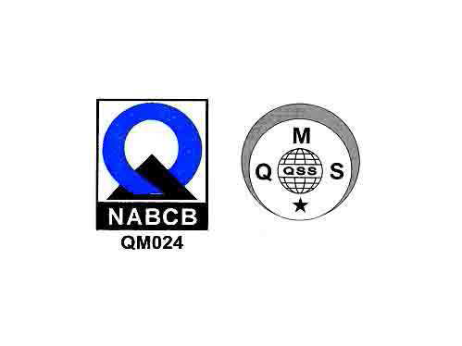
JORDAN SAFETY SYSTEMS. AN ISO 9001:2000 CERTIFIED COMPANY.

