

RESPONSE INDICATOR [ RI ]

MODEL RI-10(P) [RED]

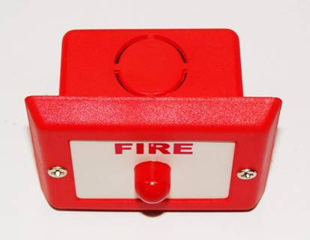

Specifications:

Operating voltage : 24V DC (max).

Current consumptions : 10mA.

Cabinet material : ABS Plastic.

Cabinet Color : Red.

Mounting : Flush Mounting/With back box

Dimensions : ( 66L x 57H x 33D )mm.

Applications : Fire alarm

JORDAN SAFETY SYSTEMS. AN ISO 9001:2000 CERTIFIED COMPANY.

